! W e l co m e ! v2.5bw

Welcome to “Friends for Life”, part of the Appalachian Homeless Mission. This is what we do.

Our Mission
We work to restore and empower homeless singles, parents and their children (our new Friends for Life) towards a "total turnaround". Our 40+ volunteers serve our Friends by partnering with dynamic churches, Christian donors and scores of available, free services.

Overview
Jesus said: “I have come that you may have life, and have it to the full." (John 10:10). That is why we, the Appalachian Homeless Mission, are here! This document will help you determine if our Mission is right for you.

In short, to fulfill our Mission:
- We design a unique solution for each Friend to achieve real, lasting turnaround.
- We offer you these comprehensive programs for as many years as you need.
- The programs address each Friend’s unique gifts and challenges.
- We help develop your strengths until you achieve comprehensive turnaround,
  - That is, until you achieve your full potential ... and happiness.
  - We are no longer a physical shelter.

We begin our partnership with you in a shelter, and often beforehand. We team up with you until you have proven your commitment to turn-around. Then we help find you housing plus help you with many other goals to help you achieve success and stability. We continue the work begun in shelters, e.g. addiction treatments, parental training.

The Mission can only work with so many families at a time so we have to limit our commitment to just those families who are genuinely committed. You will be able to measure the success of this Mission by your “self-made” - and Christ-powered - stability, happiness, hope and financial stability. After 33 years working with destitute families in four countries, the founder has learned that this kind of powerful transformation is made possible through Jesus Christ.

How Does The Mission Help Families?

The Appalachian Homeless Mission focuses on "total turnaround" to achieve a successful break with “old ways”. Bondages are often broken - surprisingly quickly – and usually in Christ. Our team works passionately with each Friend’s strengths and needs.

It is a two way street, a partnership. It is not easy and it is not for everybody. But it works!
The Appalachian Homeless Mission focuses on seven pillars to create a new life:
1. A dynamic church
2. Housing
3. Job training and placement
4. Advocacy: with bills, legal issues, government agencies ... you name it!
5. Health – help connecting to clinics,fitness, referrals to mental health counseling
6. Family training, including budgeting
7. Mentoring children and adults

Our team – to the best of our ability and resources - will start with you in this way:

- By listening and understanding, with the love of God. With open ears, respect and an open mind. Completely without judging.
- Developing Solutions Together: we identify the most pressing needs and those issues that contributed most to your becoming homeless.
- We work beside you to solve old habits and create new ones. Note: Sometimes we lack the necessary resources to provide everything above.
- After you achieve stability, we focus on our secondary aim: to help you live life to the fullest, with the kind of abundance that Christ came to give to each of us.
- Our final hope is that you then help us to help other homeless families: no one knows better than you do how hard it is to get ahead.

What we don’t do: We don’t breed dependency and we don’t give out money, except in extraordinary situations. We don’t provide licensed services. We depend on each of you to bear the load of responsibility that you are able to, but no more. God, often through us, will provide the rest. He is faithful; you will see His love and power if you chose to walk in His ways.

What You, Our Friend’s, Commit to Doing
- Commitment to Change: Families must actually want to change their lives, and show it. Changing old habits is hard and takes time. Friend’s must be fully committed. This is a two-way street; Friend’s agree to work just as hard as we do.
- Jesus: Friend’s will seriously consider learning about Jesus and finding and joining a church family. If you chose to do this:
  - We help you find a truly dynamic church, and we drive you there!
  - Friend’s then attend weekly services and mid-week Life Groups, where Christian fellowship flourishes.
- Classes: Friend’s will be willing to attend all classes and medical appointments that are necessary for their health and well-being, including DSS and CPS compliances, parenting and financial management, Christian counseling etc.
- Communications: Friend’s will keep in regular touch with us: you return calls and respond to emails promptly. (One of our many services is; we get you a phone)
- Upholding commitments. This includes attending court, job interviews and appointments, on time. (When necessary, and when able, we drive you.)
- Addictions: Serious addictions must be resolved before entering Appalachian Homeless Mission programs.
- Goals and Action Planning: Each parent will carefully use and follow-up the agreed Action plan to assure follow-through, and success. This Goal Agreement is a powerful tool towards your happiness and success. “Rules” will be followed.
- Truth and Harmony: Friend’s will be truthful and harmonious with each other, and us. (“If we walk in the light,...we will have fellowship with one another”. I John 6)
- Respect: Friend’s will show respect to one and all, including Mission staff. Part of that respect will be to dress in clean clothes and be well groomed. No slander.
- Community Work: Those Friend’s who do 3 or less job applications per day will do three hours per day of community service, either in or outside our Mission. Friends will work to repay cash advances, and pay accomodation by hours of work.

These ten commitments are for you, our Friend’s. We ask nothing for us, not now or ever. But to carry out our Mission - your success - we do require that you do these acts of love for you and your children. If you change your mind, that is totally your choice, and membership in our Mission is put on hold until you want to resume. Even of you chose to put your Life Program on hold, our friendship and our love continue!

A Mission Led by Christ:
Jesus said: "Friends, haven't you caught any fish? ... No, they answered. Throw your net on the right side of the boat and you will find some", Acts 21:5. (They followed Jesus; then the net was so heavy with fish they could not haul it in!) Christ is at the head, and the heart, of this Mission. He shows each of us the way and gives us the strength and the wisdom, very single day. We would simply fail without it.

The heart of God is at heart of the Appalachian Homeless Mission. Friend’s, come with us to the “Jesus-side” of the boat, and see what He can do for your lives!

Very Truly Yours, Hugh and Your New Friends v2.4bw
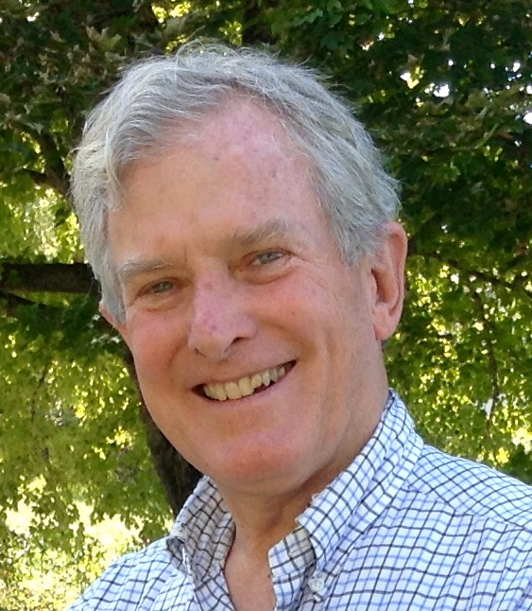
For 33 years Hugh Henderson has served the destitute in Mexico, Peru, the Dominican Republic and the Appalachians of Virginia, with Mission overhead self-funded by Hugh and his family. Hugh feels called by God to use this experience to serve, help restore and empower homeless families and their children, those without hope, without work and all too often deprived of basic justice.

